The Source code: *Refer to the python file*

1. **ANALYSIS**

Problem: Calculating collector points and recycler points and displaying the ranks/status according to the points calculated along with the points itself and some of the user’s information.

Requirements: Ask user input related to his/her personal information as well as their paper quantity, plastic quantity, oil quantity, electric quantity.

1. **REQUIREMENTS SPECIFICATION**

|  |  |  |
| --- | --- | --- |
| Input | Process | Output |
| User information (name, age, gender), paper quantity, plastic quantity, oil quantity, electric quantity | Collector points = (paper quantity*30) + (plastic quantity*50) + (oil quantity*70) + (electric quantity*90)  Recycler points = (paper quantity*40) + (plastic quantity*60) + (oil quantity*80) + (electric quantity*100)  Determining rank/status according to the points. | Displaying the rank/status along with user information, the points calculated and the remaining points to reach the next status. |

1. **CREATING DESIGN**

PSEUDO CODE FORMAT:

1. Input, Process, Output
2. Firstly, introduction message will be displayed and the user will be prompted for input (name, age, gender, paper quantity, plastic quantity, oil quantity, electric quantity) in the inputDetails function and will return all of the input values to be used in the pointCalculator and the main function.
3. Then, we’ll call the menu function in the main function, in which the user will choose whether to calculate the points, check the membership tier, reset all details being input or quit the program.
4. WHILE choice is not included among the options

4.1 Display message to inform user that he/she chose an incorrect option.

4.2 Prompt user to choose again.

4.3 If the choice is valid, the program will continue with the rest of the code. Else, the

program will prompt the user to input again.

1. The choice made is returned from the menu function so that it can be used in the main function.
2. Set two variables to None.
3. WHILE TRUE

7.1 IF the user chooses to quit

7.11 Display message to thank the user for choosing the

program and the program will stop

7.2 ELSE IF the user chooses to calculate points

7.21 Points will be calculated in the pointCalculator

function and will return both recycler and

collector points

7.22 Prompt the user to choose whether he/she will

display points as the collector or the recycler

7.23 IF user chooses collector

7.231 Display message to show user how many points

he/she earned as the collector

7.232 The user will be prompted to make the very

first choice again in the menu function

7.24 ELSE IF user chooses recycler

7.241 Display message to show user how many points

he/she earned as the recycler

7.242 The user will be prompted to make the very

first choice again in the menu function

7.3 ELSE IF user choose to display his/her membership tier

7.31 viewMembership function accepts recycler and collector points as

parameters to determine status and remaining points and return them

to be used in the main function

7.32 Prompt the user to choose whether he/she will

display his/her status as the collector or the

recycler

7.33 IF user chooses collector

7.331 IF user initially chose collector when

displaying the points

7.3311 IF user has no status

7.33111 Display message to inform

user that he/she doesn’t meet

the minimum requirements to

become the eco saver and also

how many points he/she still

needs to collect.

7.33112 The user will be prompted to

make the very first choice

again in the menu function

7.3312 ELSE IF the user is the eco saver

7.33121 Display message to

congratulate the user on

becoming the eco saver and

also inform the user

about how many points he/she

needs to collect to become

the eco hero.

7.33122 The user will be prompted to

make the very first choice

again in the menu function.

7.3313 ELSE IF the user is the eco hero

7.33131 Display message to

congratulate the user on

becoming the eco hero and

also inform the user

about how many points he/she

needs to collect to become

the eco warrior.

7.33132 The user will be prompted to

make the very first choice

again in the menu function.

7.3314 ELSE IF the user is the eco warrior

7.33141 Display message to

congratulate the user on

becoming the eco warrior.

7.33142 The user will be prompted to

make the very first choice

again in the menu function.

7.332 ELSE IF user initially chose recycler when

displaying the points

7.3321 IF user didn’t choose collector when

going back to the menu to display the

points and the first variable remain None

7.33211 Display message to inform

user that there is no

collector point.

7.33212 The user will be prompted to

make the very first choice

again in the menu function.

7.3322 IF user chose collector when

going back to the menu to display the

points and the first variable is no

longer None

7.33221 IF user has no status

7.332211 Display message to

inform user that

user that he doesn’t

meet the minimum

requirements to

become the eco saver

and also, how many

points he/she still

needs to collect

7.332212 The user will be

prompted to make the

very first choice

again in the menu function

7.33222 ELSE IF the user is the eco

saver

7.332221 Display message to

congratulate the

user on becoming the

eco saver and also

inform the user

about how many

points he/she needs

to collect to become

the eco hero.

7.332222 The user will be

prompted to make the

very first choice

again in the menu function

7.33223 ELSE IF the user is the eco

hero

7.332231 Display message to

congratulate the

user on becoming the

eco hero and also

inform the user

about how many

points he/she needs

to collect to become

the eco warrior.

7.332232 The user will be

prompted to make the

very first choice

again in the menu function

7.33224 ELSE IF the user is the eco

warrior

7.332241 Display message to

congratulate the

user on becoming the

eco warrior.

7.332242 The user will be

prompted to make the

very first choice

again in the menu function

7.34 IF user chooses recycler

7.341 IF user initially chose recycler when

displaying the points

7.3411 IF user has no status

7.34111 Display message to inform

user that he/she doesn’t meet

the minimum requirements to

become the eco saver and also

how many points he/she still

needs to collect.

7.34112 The user will be prompted to

make the very first choice

again in the menu function

7.3412 ELSE IF the user is the eco saver

7.34121 Display message to

congratulate the user on

becoming the eco saver and

also inform the user

about how many points he/she

needs to collect to become

the eco hero.

7.34122 The user will be prompted to

make the very first choice

again in the menu function

7.3413 ELSE IF the user is the eco hero

7.34131 Display message to

congratulate the user on

becoming the eco hero and

also inform the user

about how many points he/she

needs to collect to become

the eco warrior.

7.34132 The user will be prompted to

make the very first choice

again in the menu function

7.3414 ELSE IF the user is the eco warrior

7.34141 Display message to

congratulate the user on

becoming the eco warrior.

7.34142 The user will be prompted to

make the very first choice

again in the menu function

7.342 ELSE IF user initially chose collector when

displaying the points

7.3421 IF user didn’t choose recycler when

going back to the menu to display the

points and the second variable remain None

7.33211 Display message to inform

user that there is no

recycler point.

7.34212 The user will be prompted to

make the very first choice

again in the menu function

7.3422 IF user chose recycler when going

back to the menu to display the

points and the second variable is

no longer None

7.34221 IF user has no status

7.342211 Display message to

inform user that

user that he doesn’t

meet the minimum

requirements to

become the eco saver

and also, how many

points he/she still

needs to collect

7.342212 The user will be

prompted to make the

very first choice

again in the menu function

7.34222 ELSE IF the user is the eco

saver

7.342221 Display message to

congratulate the

user on becoming the

eco saver and also

inform the user

about how many

points he/she needs

to collect to become

the eco hero.

7.342222 The user will be

prompted to make the

very first choice

again in the menu function

7.34223 ELSE IF the user is the eco

hero

7.342231 Display message to

congratulate the

user on becoming the

eco hero and also

inform the user

about how many

points he/she needs

to collect to become

the eco warrior.

7.342232 The user will be

prompted to make the

very first choice

again in the menu function

7.34224 ELSE IF the user is the eco

warrior

7.342241 Display message to

congratulate the

user on becoming the

eco warrior.

7.342242 The user will be

prompted to make the

very first choice

again in the menu function

7.4 ELSE IF user chooses to reset all details

7.41 Display message to inform user that all

information has been reset.

7.42 The user will now be prompted to input

new details in the inputDetails function

and then make the very first choice

again in the menu function.

Note: Refer to question 1 or py file to see the explanations for complex parts of the code.

1. **IMPLEMENTING THE DESIGN**

The design has already been implemented.

1. **TESTING/DEBUGGING**

**TESTING**

The “TypeError” I got is related to concatenation where I used (+) to concatenate an integer and a string.

Error: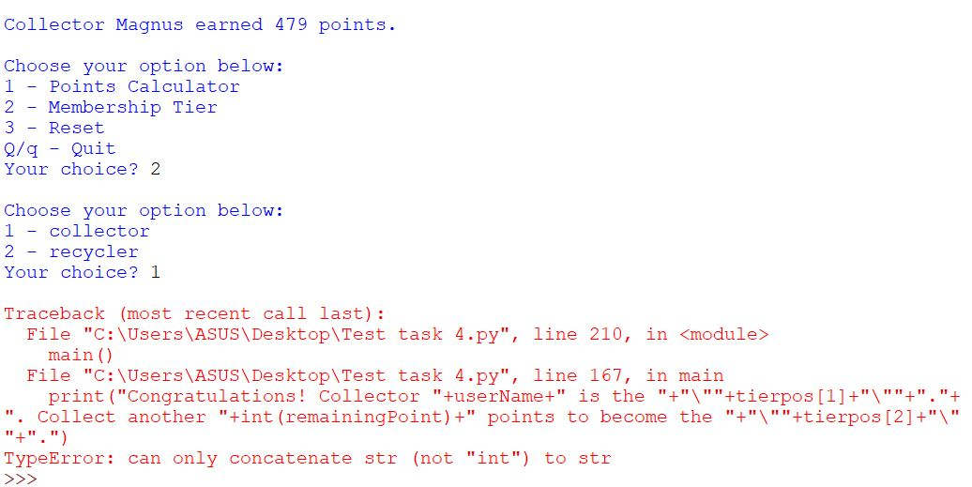

**DEBUGGING**

I fixed the problem by using comma (,) instead of (+). The spacings are also removed.

Fixation:

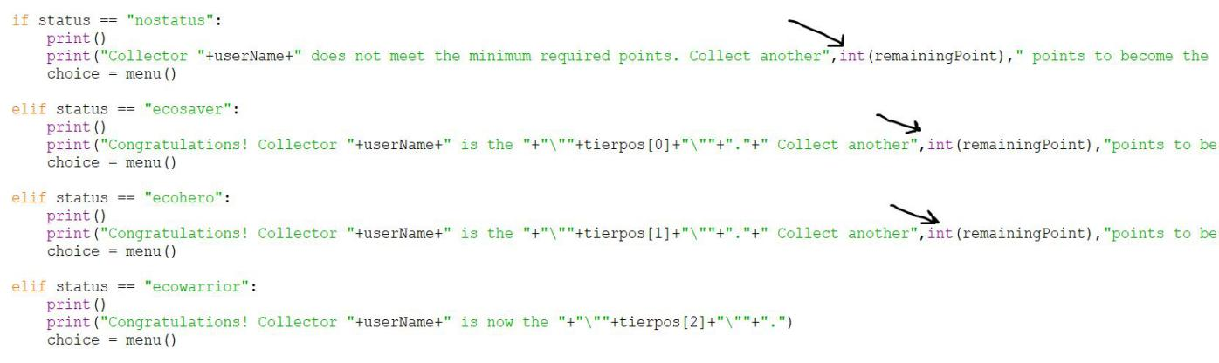

**TESTING continued…**

After I fixed the error, I tested the program with two different inputs as well. The program worked smoothly without any error and the correct calculated points along with the correct membership tier and correct remaining points to reach a status were displayed.

Test runs are as follows:

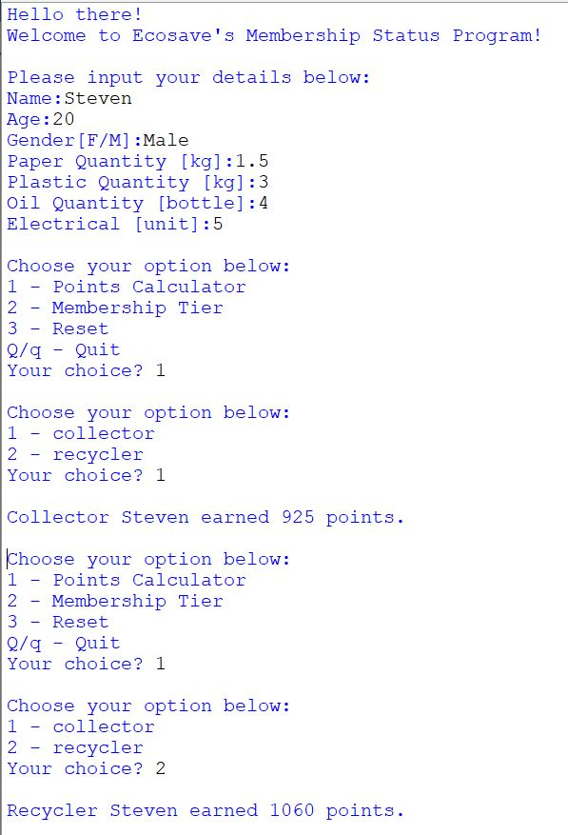

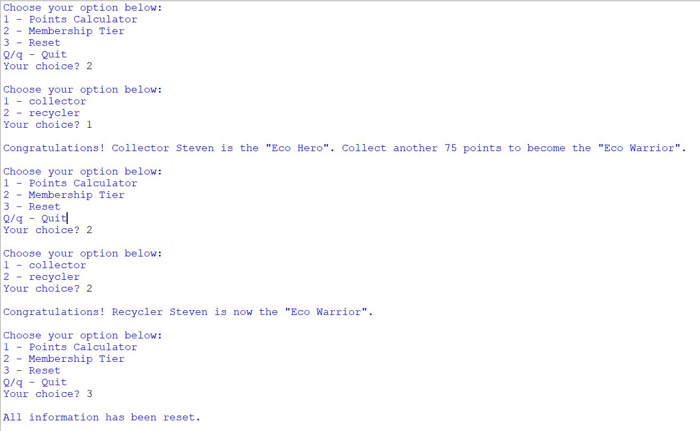

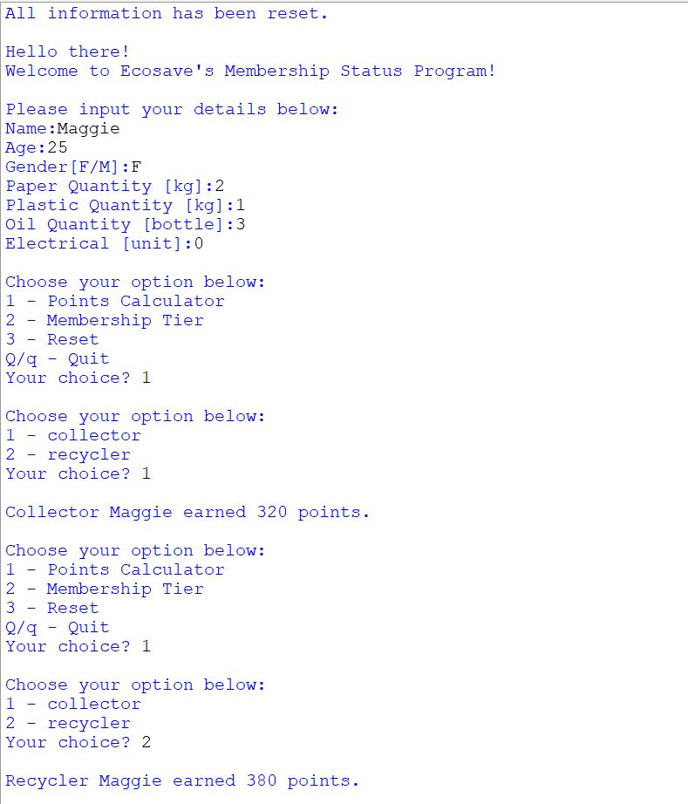

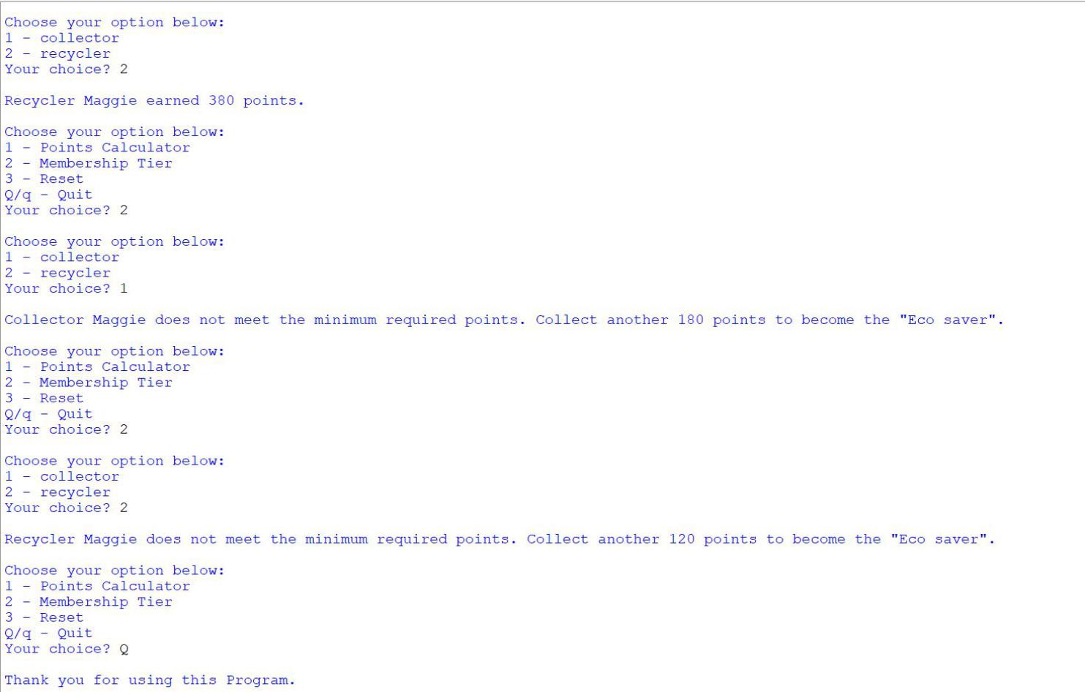

1. **MAINTENANCE**

As a programmer, I realize that even though I’m done with making a program that provide the users with their current needs, the program is not completely finished by any means.

There’s no denying that in the future, the users will demand more information and functionality out of the program which means there’ll be more problems and the program will require updating. I also realize that it is a necessity for me to be attentive to whatever the users need and also their feedbacks so that I can make their requirements accessible by updating the program. For example, let’s say some users give me a feedback that the minimum points requirement for the membership status “eco saver” is too high and they want either another rank to be added or lower the current minimum points requirement for “eco saver”. If I lower the minimum points, it will not be fair for other users who earned enough minimum points. So, I will instead create a new status called “eco contributor” which require 300 minimum points only. Then, I will update the program by adding a new if statement for “eco contributor” status in the viewMembership function. In another case, the users who have already reached the “eco warrior” status will remain to be “eco warrior” no matter how many points they continue to collect in the future. They will ask for another membership tier as well. Then, I will need to set minimum required points according to EcoSave and add a new if statement for the new rank in the viewMembership function as well. These are some of the case scenarios of new user demands that can be implemented by updating the program itself.

In conclusion, the maintenance of a program solely depends on the attentiveness of the programmer for users’ demands that will contribute to the evolution of the program itself.